

**GRAVTY Implementation Blueprint**



GLOSSARY

### 

Table of Contents

1 GRAVTY Implementation for ICICI Bank Program 5

1.1 ICICI Bank Program Setup 5

1.1.1 ICICI Bank Program Details 5

1.1.2 ICICI Bank Loyalty Accounts 5

1.2 Program Policies 7

2.1 Enrollment rules 12

3.1 Sponsor Setup 13

3.1.1 Three tier structure of ICICI Bank 19

3.1 Offer Setup 20

### 

### 

### 

### 

### 

### 

### 

|  |  |  |  |
| --- | --- | --- | --- |
| S No. | Definition | Description | Example |
| 1 | SPONSOR | Sponsor: an entity participating in the program, typically offering products and services for program members to earn loyalty rewards or redeem.   * A sponsor may also serve as an acquisition vehicle for the program to enroll customers into the loyalty program. * A Sponsor is essentially a ‘transacting’ entity or in other words an entity to which members of the loyalty program interact directly (in order to say Earn or Burn points)   A Sponsor can be a   * Line of Business (e.g. Uber Eats – Part of Uber) * Brand (e.g. Honda, LG, Yocket) * Partner (e.g. Zoomcar Car Rental, partner with AAdvantage – American Airlines’ Loyalty program) * Supplier (e.g. L’Oreal – supplier to Macy’s) | Examples of Sponsor in the context of ICICI Bank Program are: Hamleys, goibibio.com, Paytm etc. |
| 2 | PRIVILEGES | Program Benefits that aren’t related to Points. A Privilege can be   * Earned (e.g. Top 5 spenders with best answers will get a fully paid family trip to peppa pig live musical show) * Bought or Redeemed (in Points and/or Cash) e.g. Live musical show Ticket in 2000 Rewards Points * Granted (e.g. live musical show Ticket   Complimentary as your Birthday Gift) | Program Benefits |
| 3 | LOCATIONS | Location in GRAVTY is a place of business for the Sponsor. A location is where customer engagement strategies are executed and realized. A location could be a store, a cinema hall, a mall tenant, a hotel restaurant or an entertainment outlet. | Store |
| 4 | BIT | BIT is the acronym for Behaviours, Influences, Transactions and represents an instance of a member’s engagement with a brand. BIT represents the new 3D customer value referred to as BIT ValueTM.. | First Citizen Member’s Behaviors and Transactions |

|  |  |  |  |
| --- | --- | --- | --- |
| 5 | OFFER | An offer encapsulates the value proposition  delivered to customers in order to engage. A brand may engage customers to: attract, acquire, reward, recognize, retain, leverage in order to maximize a member’s lifetime value and profitability. Each offer may have specific short-term or long-term business goals, that are set and tracked through specific Key Performance Indicators. An offer can be a  Reward, Award, Privilege or a Deal | Offers to deliver  layered rewards. |
| 6 | REWARD  OFFER | Reward Offer is an Offer wherein members earn rewards (points, cash-back, experiential) for fulfilling an underlying or call to action | ICICI Bank Points accrued by a member for activities with a participating  brand. |
| 7 | AWARD  OFFER | Award Offer is an Offer wherein members can redeem their points/loyalty assets they have earned for products/services/special  moments offered by the program | Redeeming ICICI Bank Points for a ticket to a concert |
| 8 | PRIVILEGE  OFFER | Privilege Offer is an Offer wherein the program can grant gifts (GVs) or entitlements (free parking) to members without any pre- condition or call to action. These could be Surprise & Delight or even Service Recovery strategies. | Free parking for members who have transacted with City Center at least 3 times a week for 4 continuous weeks |
| 9 | MEMBERSHIP  STAGE | Membership Stage is the mechanic by which a loyalty and engagement program can systematically manage the lifecycle of members in the program and determine a member’s eligibility to earn rewards, redeem points (awards), avail Privileges, and access program offers. GRAVTY includes 3 system defined/seeded membership stages (Active, Merged & Cancelled) with the flexibility to create any number of membership stages  relevant to the program. | sClosed, Disabled, Dormant, New, Suspended, Test |
| 10 | LOYALTY  ASSETS | Benefits earned by a Program member in the  form of Points, Cashback, Experiences, |  |
| 11 | ACTIVITY | An activity is any engagement of a member with a program. It could be a transactional purchase or an award redemption or an MGM referral or a transfer of points to another  member or staff or institutions like a Charity. |  |

# **GRAVTY Implementation for ICICI Bank Program**

## ICICI Bank Program Setup

### ICICI Bank Program Details

Program definition in GRAVTY includes setting up

* ICICI Bank as the Host of the Program
* India as the Home country for the Program. Based on the Home country selection the following parameters are automatically chosen by GRAVTY:
  + Date Format
  + Temperature Format
  + Timezone and
  + Currency Format
* Decimal selection – which is used throughout the Program to report Program member’s Point balance, as well as:

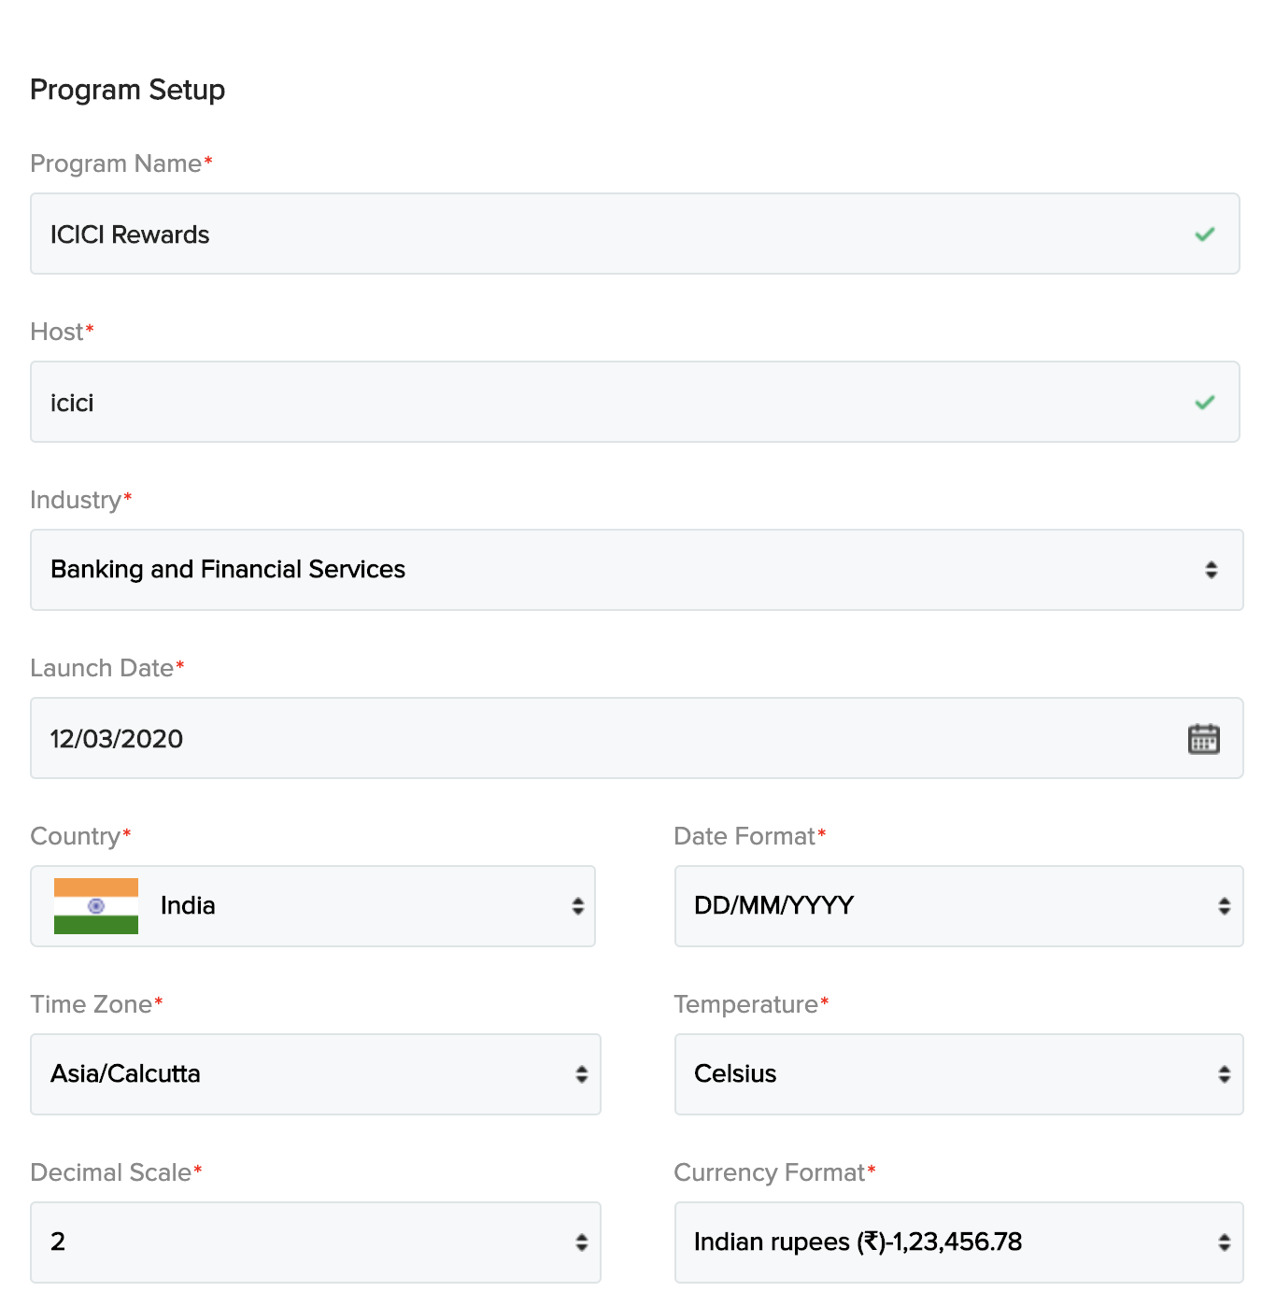

ICICI Bank Program Setup

## ICICI Bank Loyalty Accounts

We have setup the following Loyalty Accounts in GRAVTY:

* GRAVTY uses the external account to capture the cashback for members
* Members will get the cashback from the offers and these cashbacks get increased with every offer availed by members.
* Cashbacks will be stored in the external loyalty account and will be displayed in the iMobile application of ICICI.

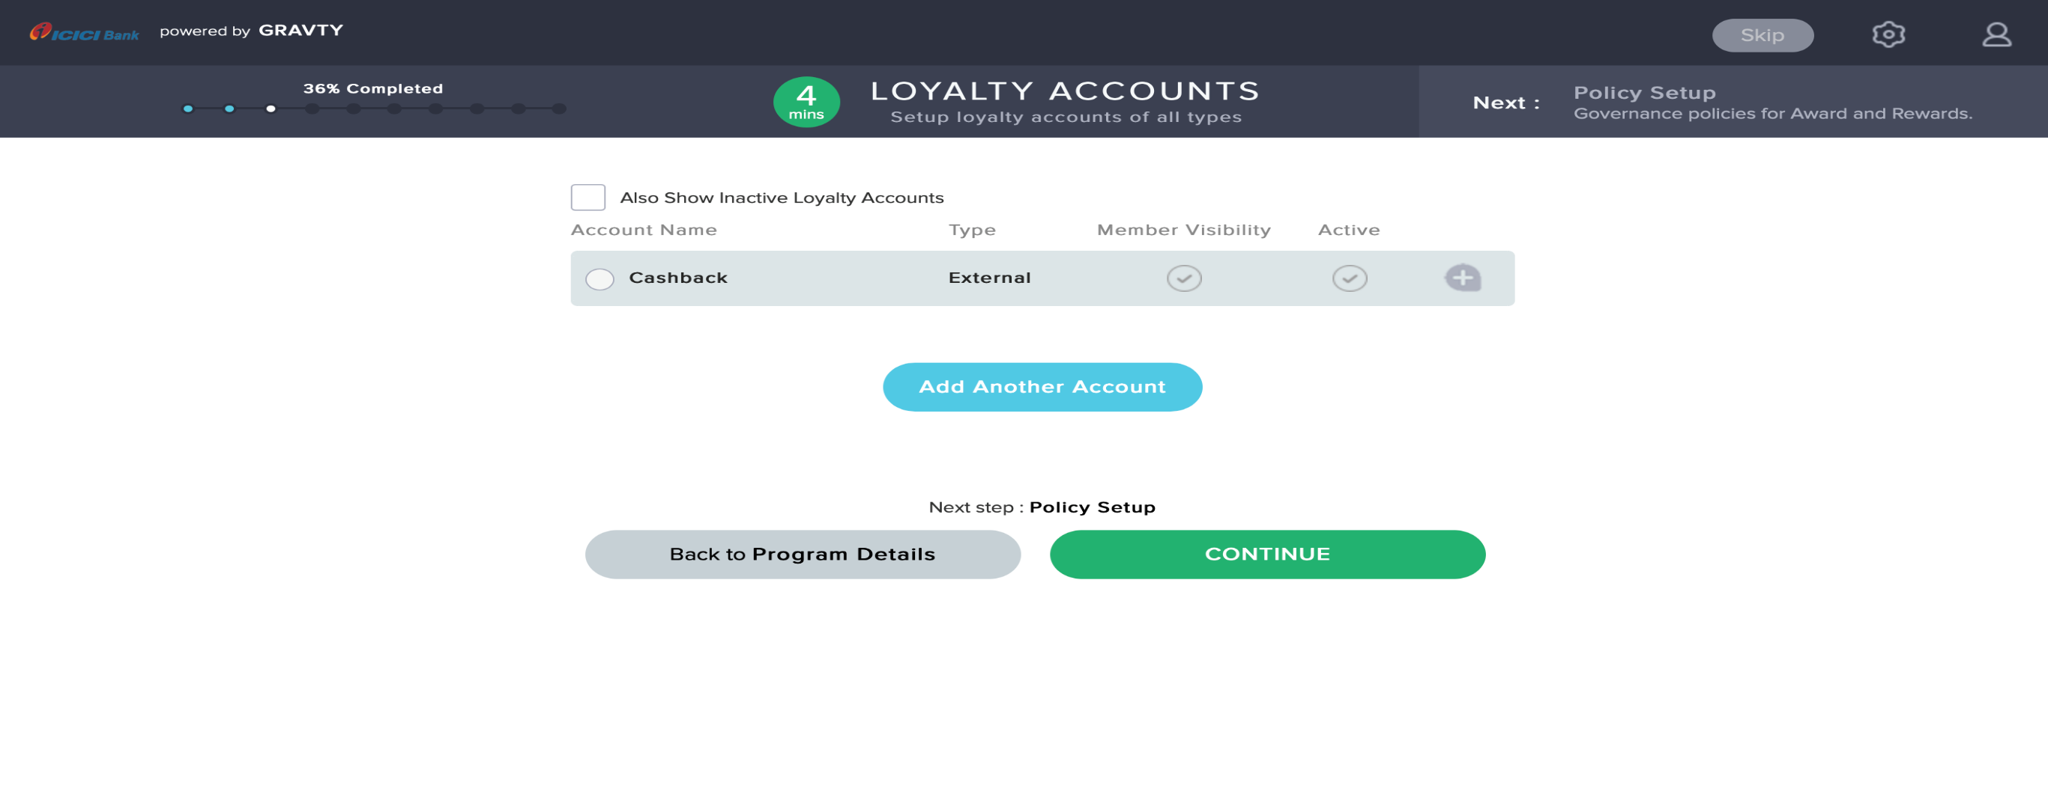

ICICI Bank Loyalty Account for cashbacks

#### 1.1.2.1 ICICI Cashbacks

ICICI Bank Cashbacks is the currency of the ICICI Bank Program. ICICI Bank Program members will earn Cashbacks for their qualified BITs / Transactions with ICICI Bank.

These Cashbacks are shown at member level on iMobile app in cumulative form as well as how much did the member get cashback per transaction/offer.

ICICI Bank Program members can redeem Cashbacks in a variety of ways including making payments, Money Transfer to Payee, Any bill payment, Make any UPI-VPA payment, Book Rail, flight, Hotel, Bus ticket, Order Food, etc

ICICI Bank Points Account set up includes:

1. Name and Description
2. Account Type: External

## **1.2 Program Policies**

Program Policies determine the overall governance model for ICICI Bank program related Rewards, Awards and Membership Lifecycle Management configured as follows:

#### 1.2.1 Member Data Model

Member Data Model Policy include setting up the attributes of ICICI Bank members. All the attributes which are configured here are the customer level attributes.

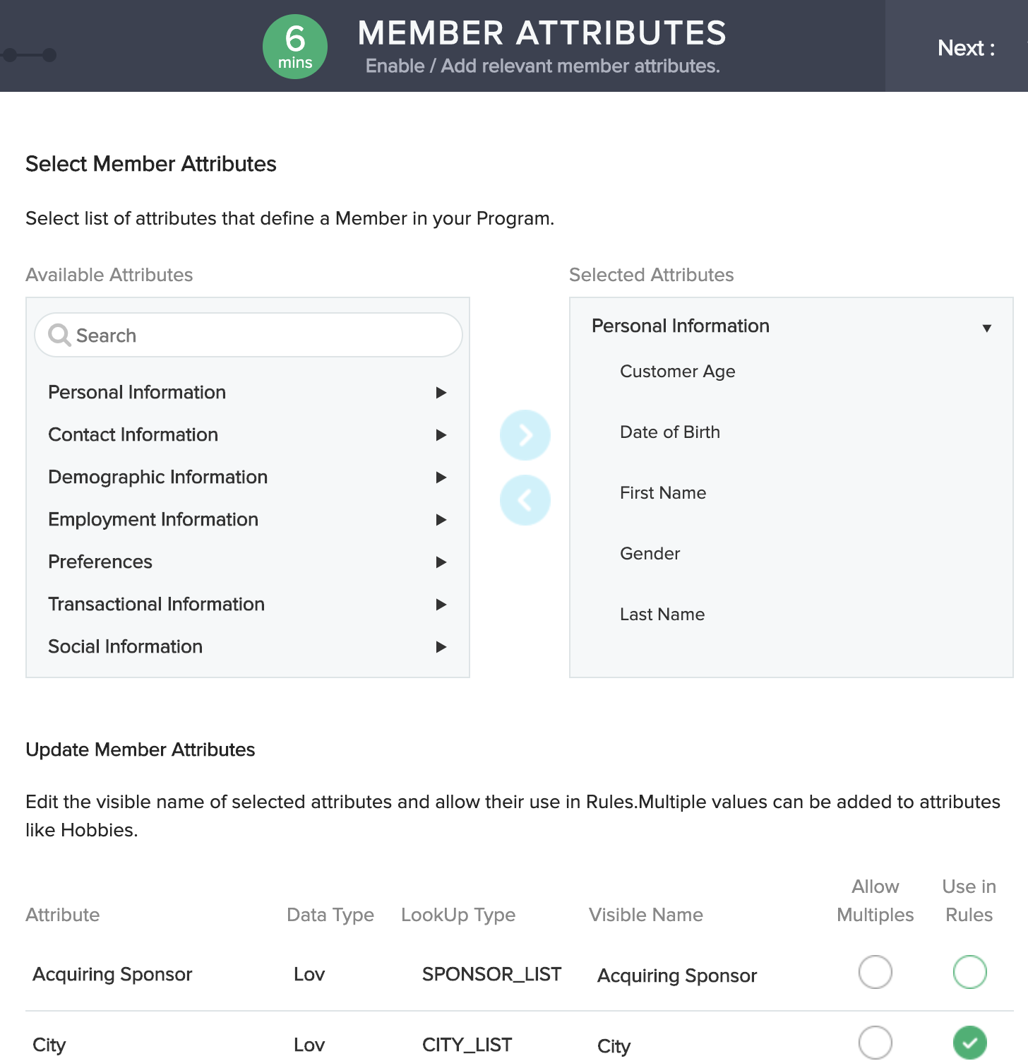

Attrubutes configured till now are listed below

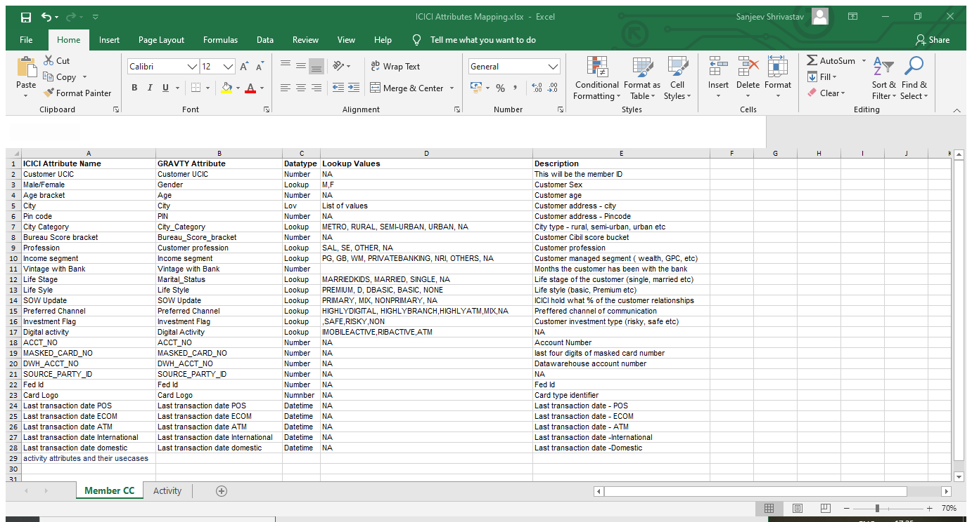

#### 1.2.2 Activity Data Model

Activity Data Model Policy include details regarding the transaction attributes to be used for ICICI Bank members. Each attribute can be used to configure the offer and capture in the transaction details.

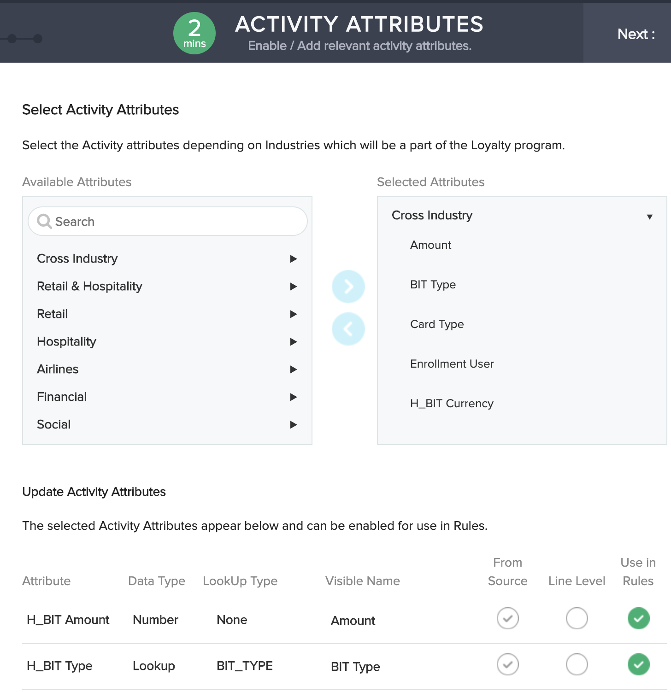

Some attributes which are configuted for transaction details

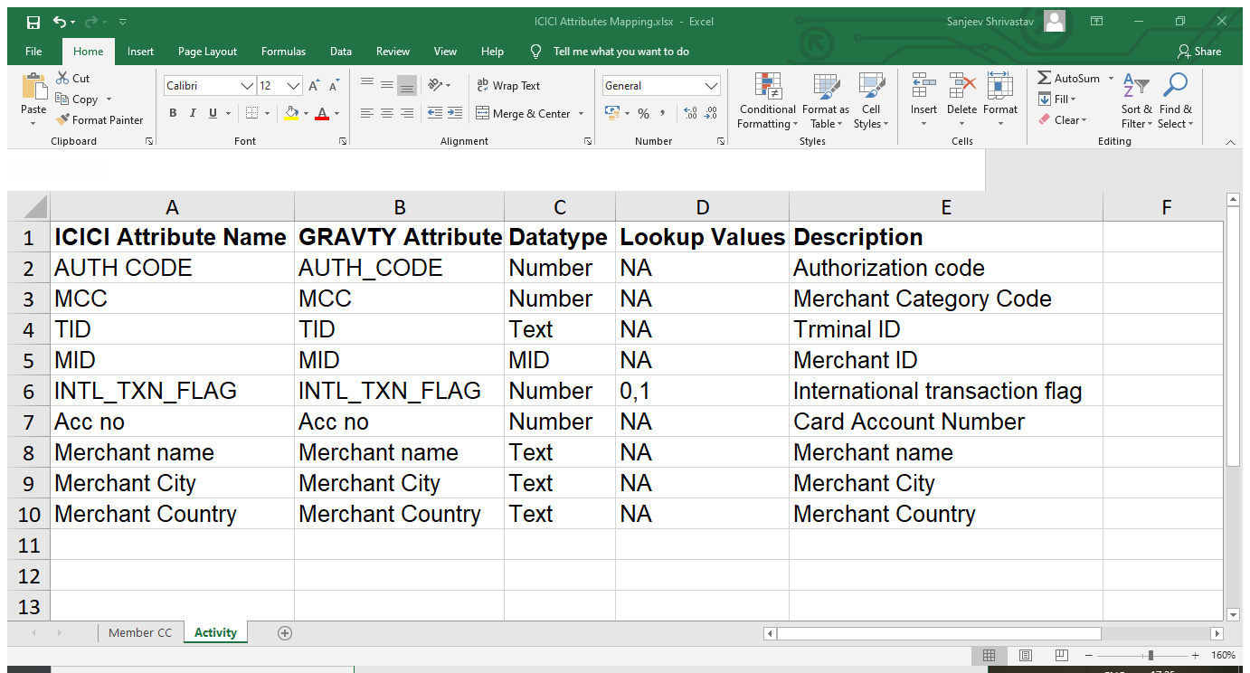

#### 1.2.3 Membership Policies

1.2.3.1 ICICI Bank Member Lifecycle Stages Setup

Membership Stage signifies the member's engagement maturity with the Program.

GRAVTY assigns a specific Membership Stage to each ICICI Bank Program Member, from the time of enrollment and programmatically changes the Membership Stage based on Program Rules (refer to Enrollment Rule )

Membership Stage of a member determines his/her specific entitlements (as described below) as a Member of ICICI Bank Program based on the program policies:

1. Access to Rewards: Can earn cashbacks
2. Access to Awards: Can redeem cashbacks
3. Access to Privileges: Can avail Privileges
4. Access to Offers: Can be targeted for a specific Offer
5. Access to Login: Member’s permission to login to the program

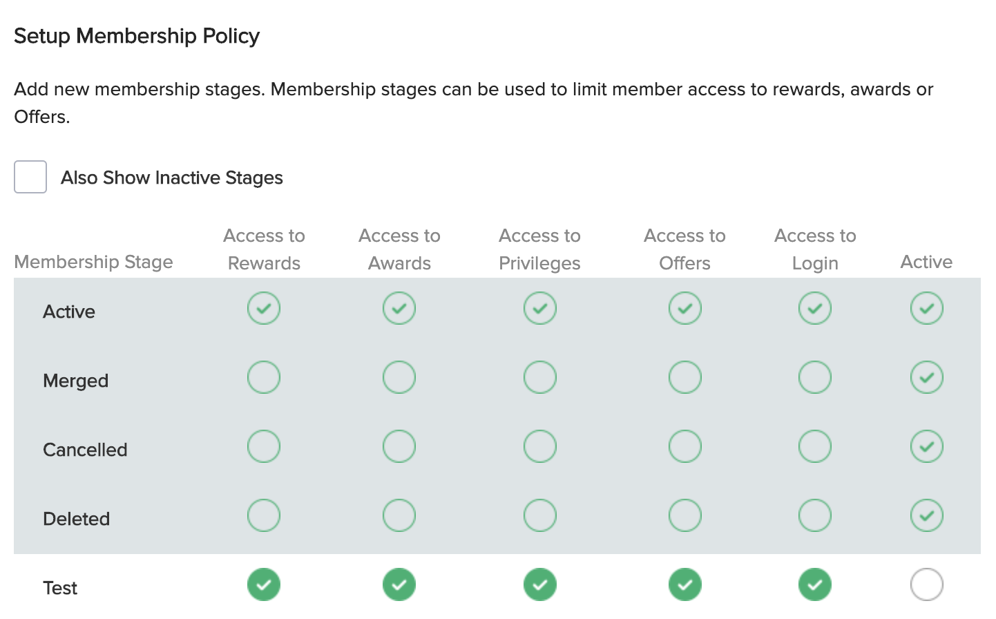

ICICI Bank Program Membership Stages and Entitlements

GRAVTY provides the following *seeded* Membership Stages. GRAVTY’s internal processes use these Membership Stages (as described below), hence can’t be deleted by the ICICI Bank Program User.

ACTIVE: GRAVTY assigns this Membership Stage by default to every new member enrolling into the Loyalty Program in case the Program doesn’t use any Programmatic rules to assign a different Membership Stages. Alternatively, Program User can configure rules to assign ACTIVE membership stage on occurrence of a specific event (e.g. Email verified, Upon First Transaction, etc.). Members in ACTIVE Membership Stage are allowed to Earn cashbacks, Redeem cashbacks , Receive Offers and Avail Privileges. A membership stage is Active only when it is not from Other countries and has done some transactions.

MERGED: GRAVTY assigns MERGED Stage to a Membership that is merged with another Membership. MERGED Membership Stage is not available for Program Users to assign through Rules, instead it is used internally by Membership Merge process in GRAVTY.

Members in MERGED Membership Stage are not allowed to Earn cashback, Redeem cashback, Receive Offers and Avail Privileges.

CANCELLED: GRAVTY assigns CANCELLED Stage to Membership that are cancelled. CANCELLED Membership Stage is not available for Program Users to assign through Rules, instead it is used internally by Membership Cancellation Process in GRAVTY.

Members in CANCELLED Membership Stage are not allowed to Earn cashback, Redeem cashback, Receive Offers and Avail Privileges.

DELETED: Members which are deleted by the program host or by any customer service agent are assigned a tag called DELETED. Members in Deleted Membership Stage are not allowed to Earn cashback, Redeem cashback, Receive Offers and Avail Privileges.



The 4 Seeded Membership Stages as described are always Active and can’t be De- activated by the Program users. The Entitlements setup for each of these seeded Membership Stages are pre-determined and can’t be changed by the Program users.

#### 1.2.4 Loyalty Assets Transfer Setup

Loyalty Assets Transfer Setup involves defining permissible transfers of Loyalty Assets: mainly Points and Privileges.

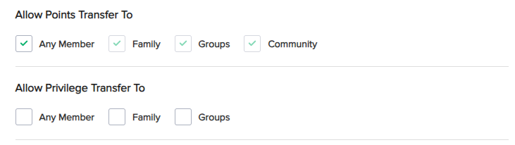

Loyalty Program Assets Transfer Setup

We have set this up to transfer ICICI Bank Points to any member, as per the current ICICI Bank Program Policies.

#### 1.2.5 Family Setup

This involves

* Setting up a time interval for ICICI Bank Program members to unlink with his/her current Family Head and linking to another Family Head. We have set this up as 15 days, which means ICICI Bank Member, who is linked to a Family Head (say X) can’t unlink with X and link with another Family Head (say Y) within a 15-day time interval, that means a member can anytime unlink himself from the family head and vice versa.
* A Family Member may unlink from the Family Head, and relink with the same Family Head, anytime they wish as long as it doesn’t exceed max Member per family limit – the time interval applies for the same Member to link with another Family Head.
* Setting up max permissible size of the Family in ICICI Bank Program (including Family Head). We have set this up as 4, as per the ICICI Bank Program policies.

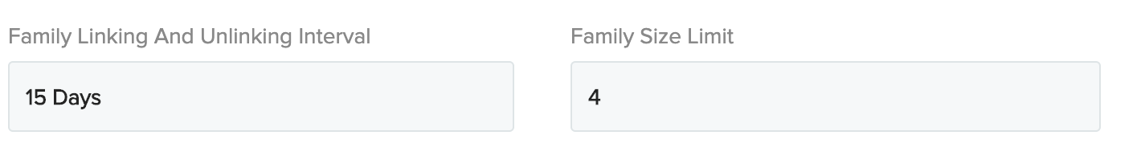

## **2.1 Enrollment rules**

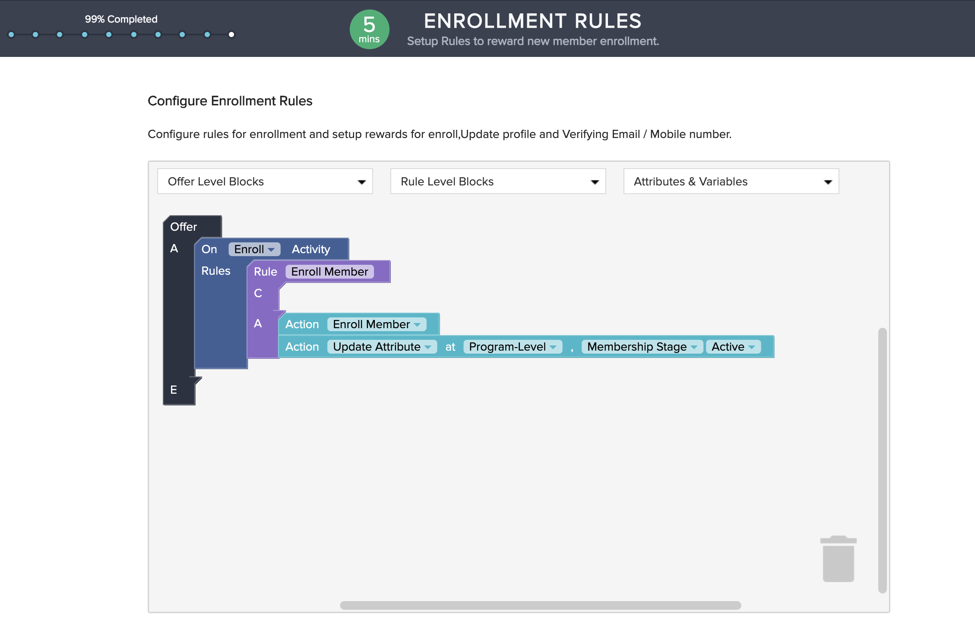

The enrollment rule states a logic that when the member enrolls himself into the program his membership stage is updated to active.

## 

## **3.1 Sponsor Setup**

We have setup following Sponsors in GRAVTY as per the structure depicted above.

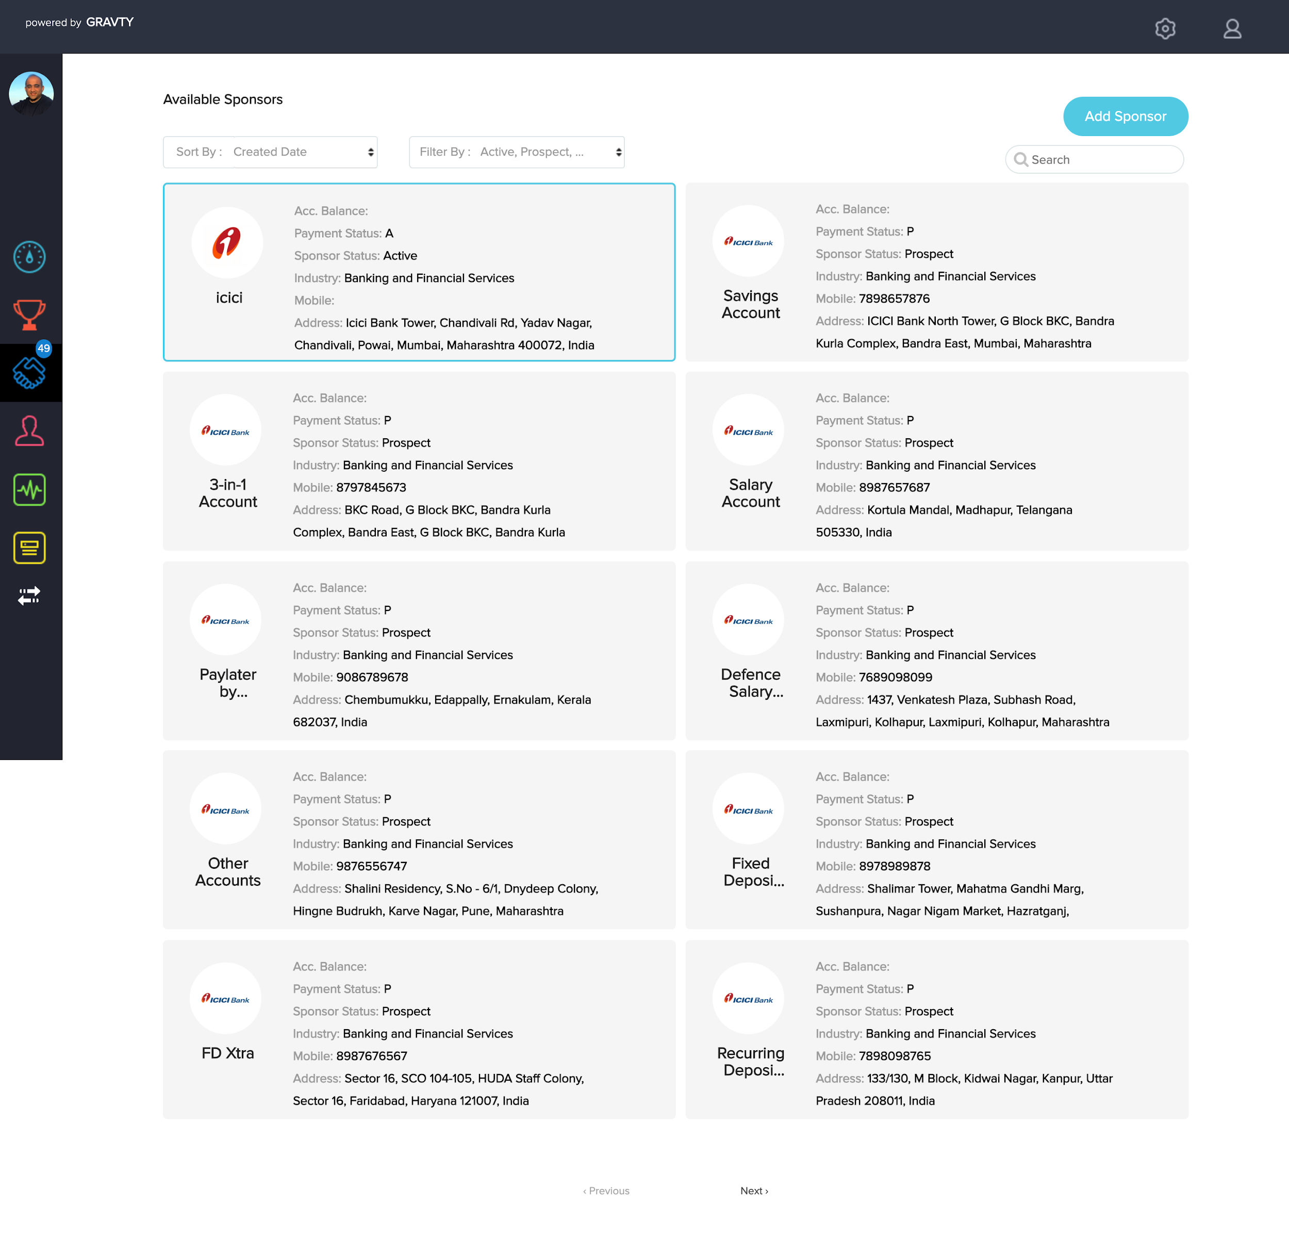

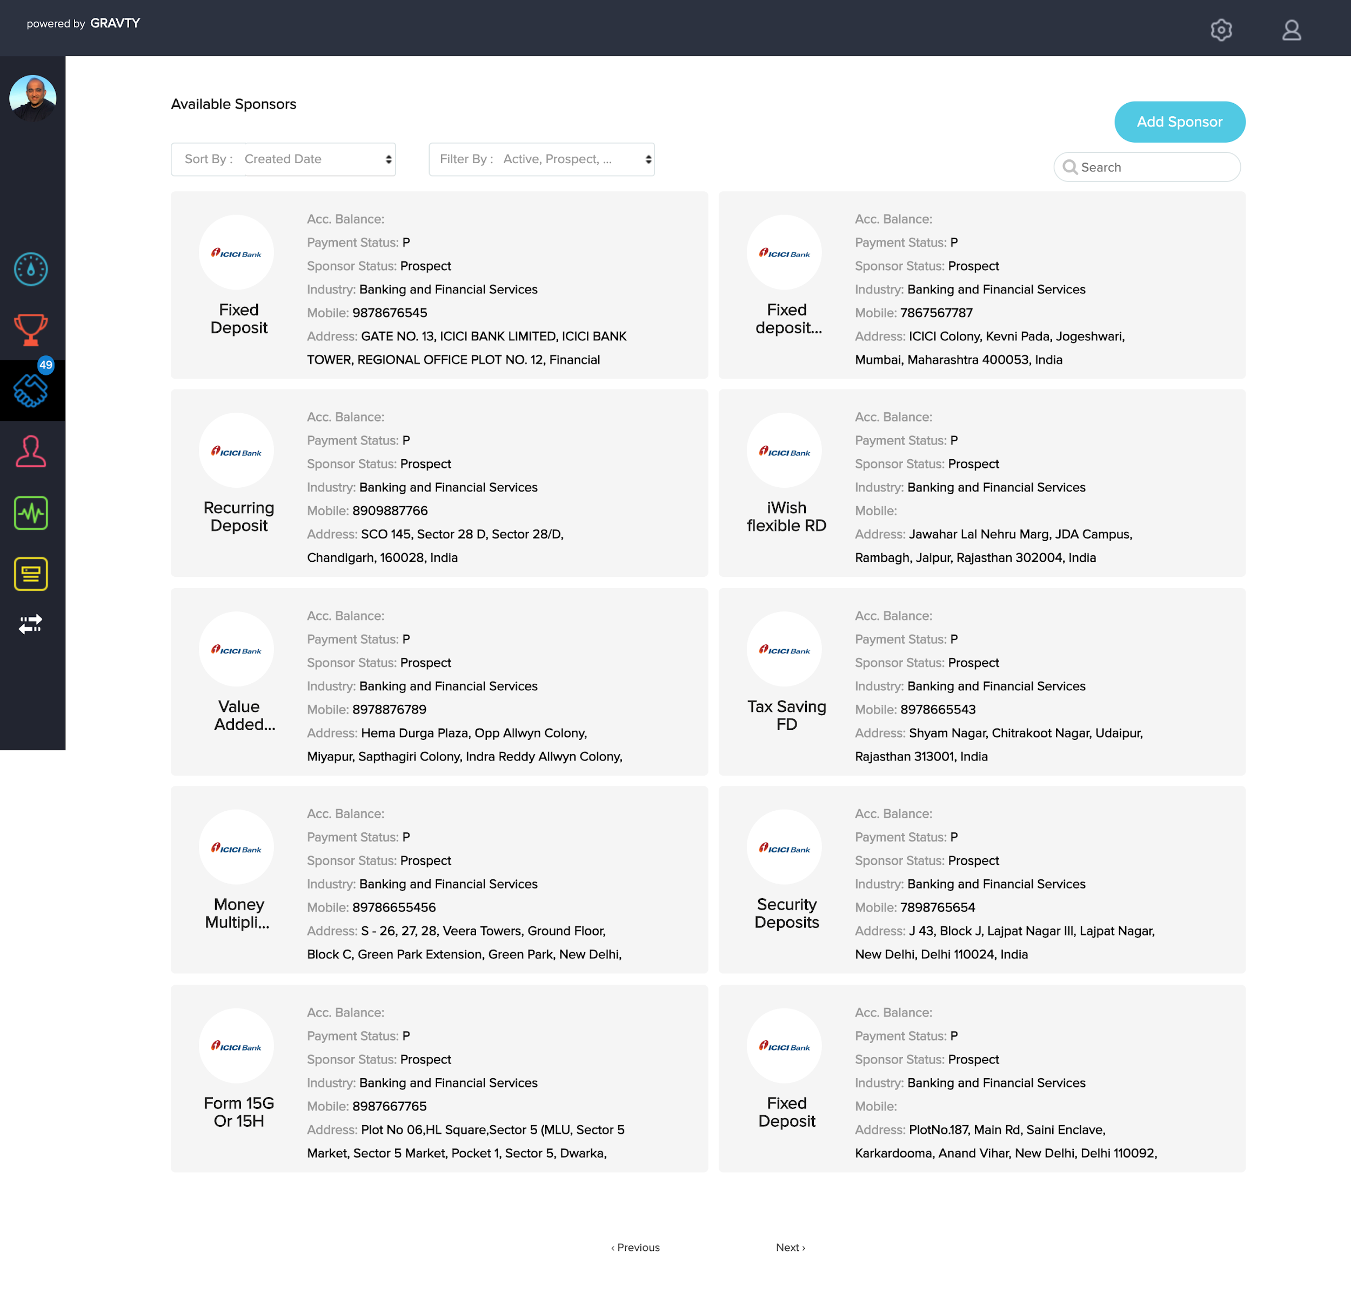

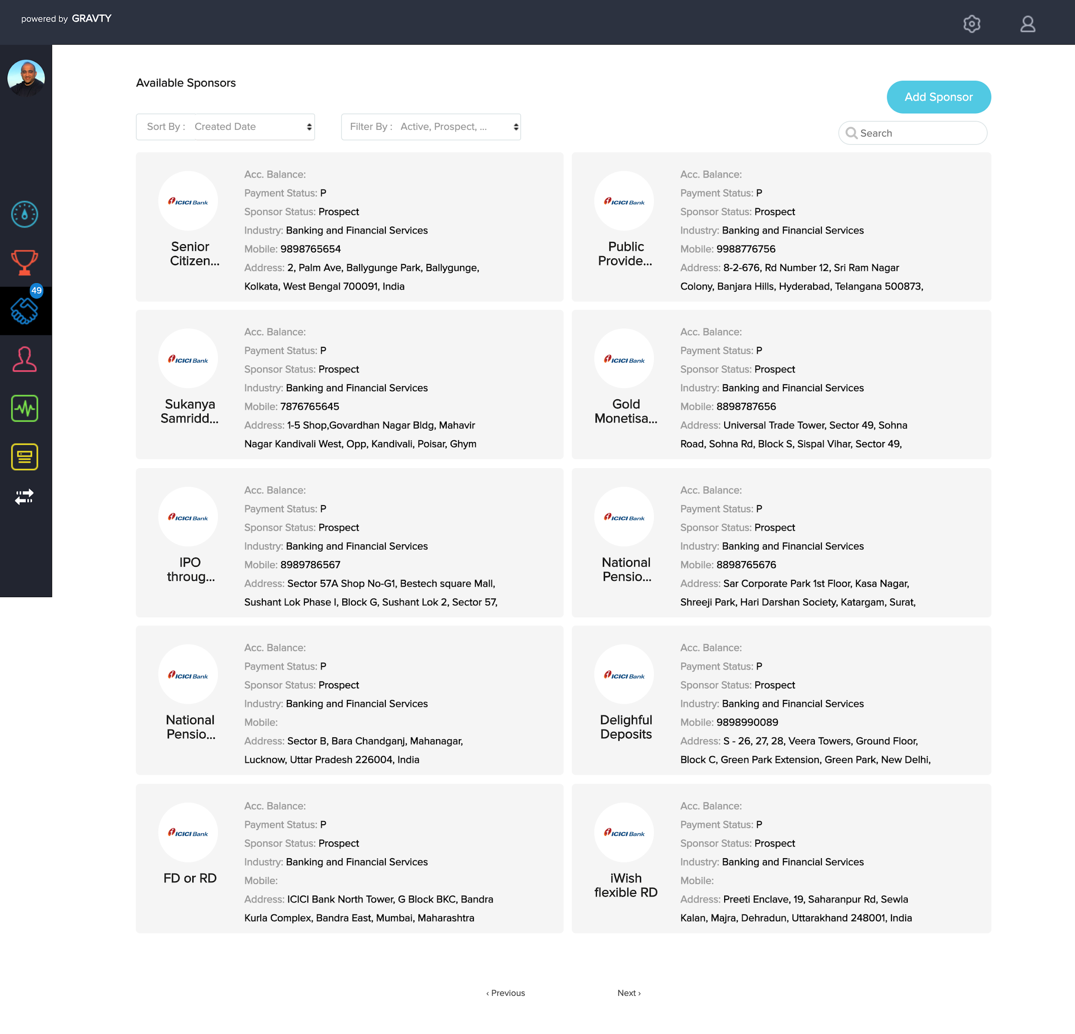

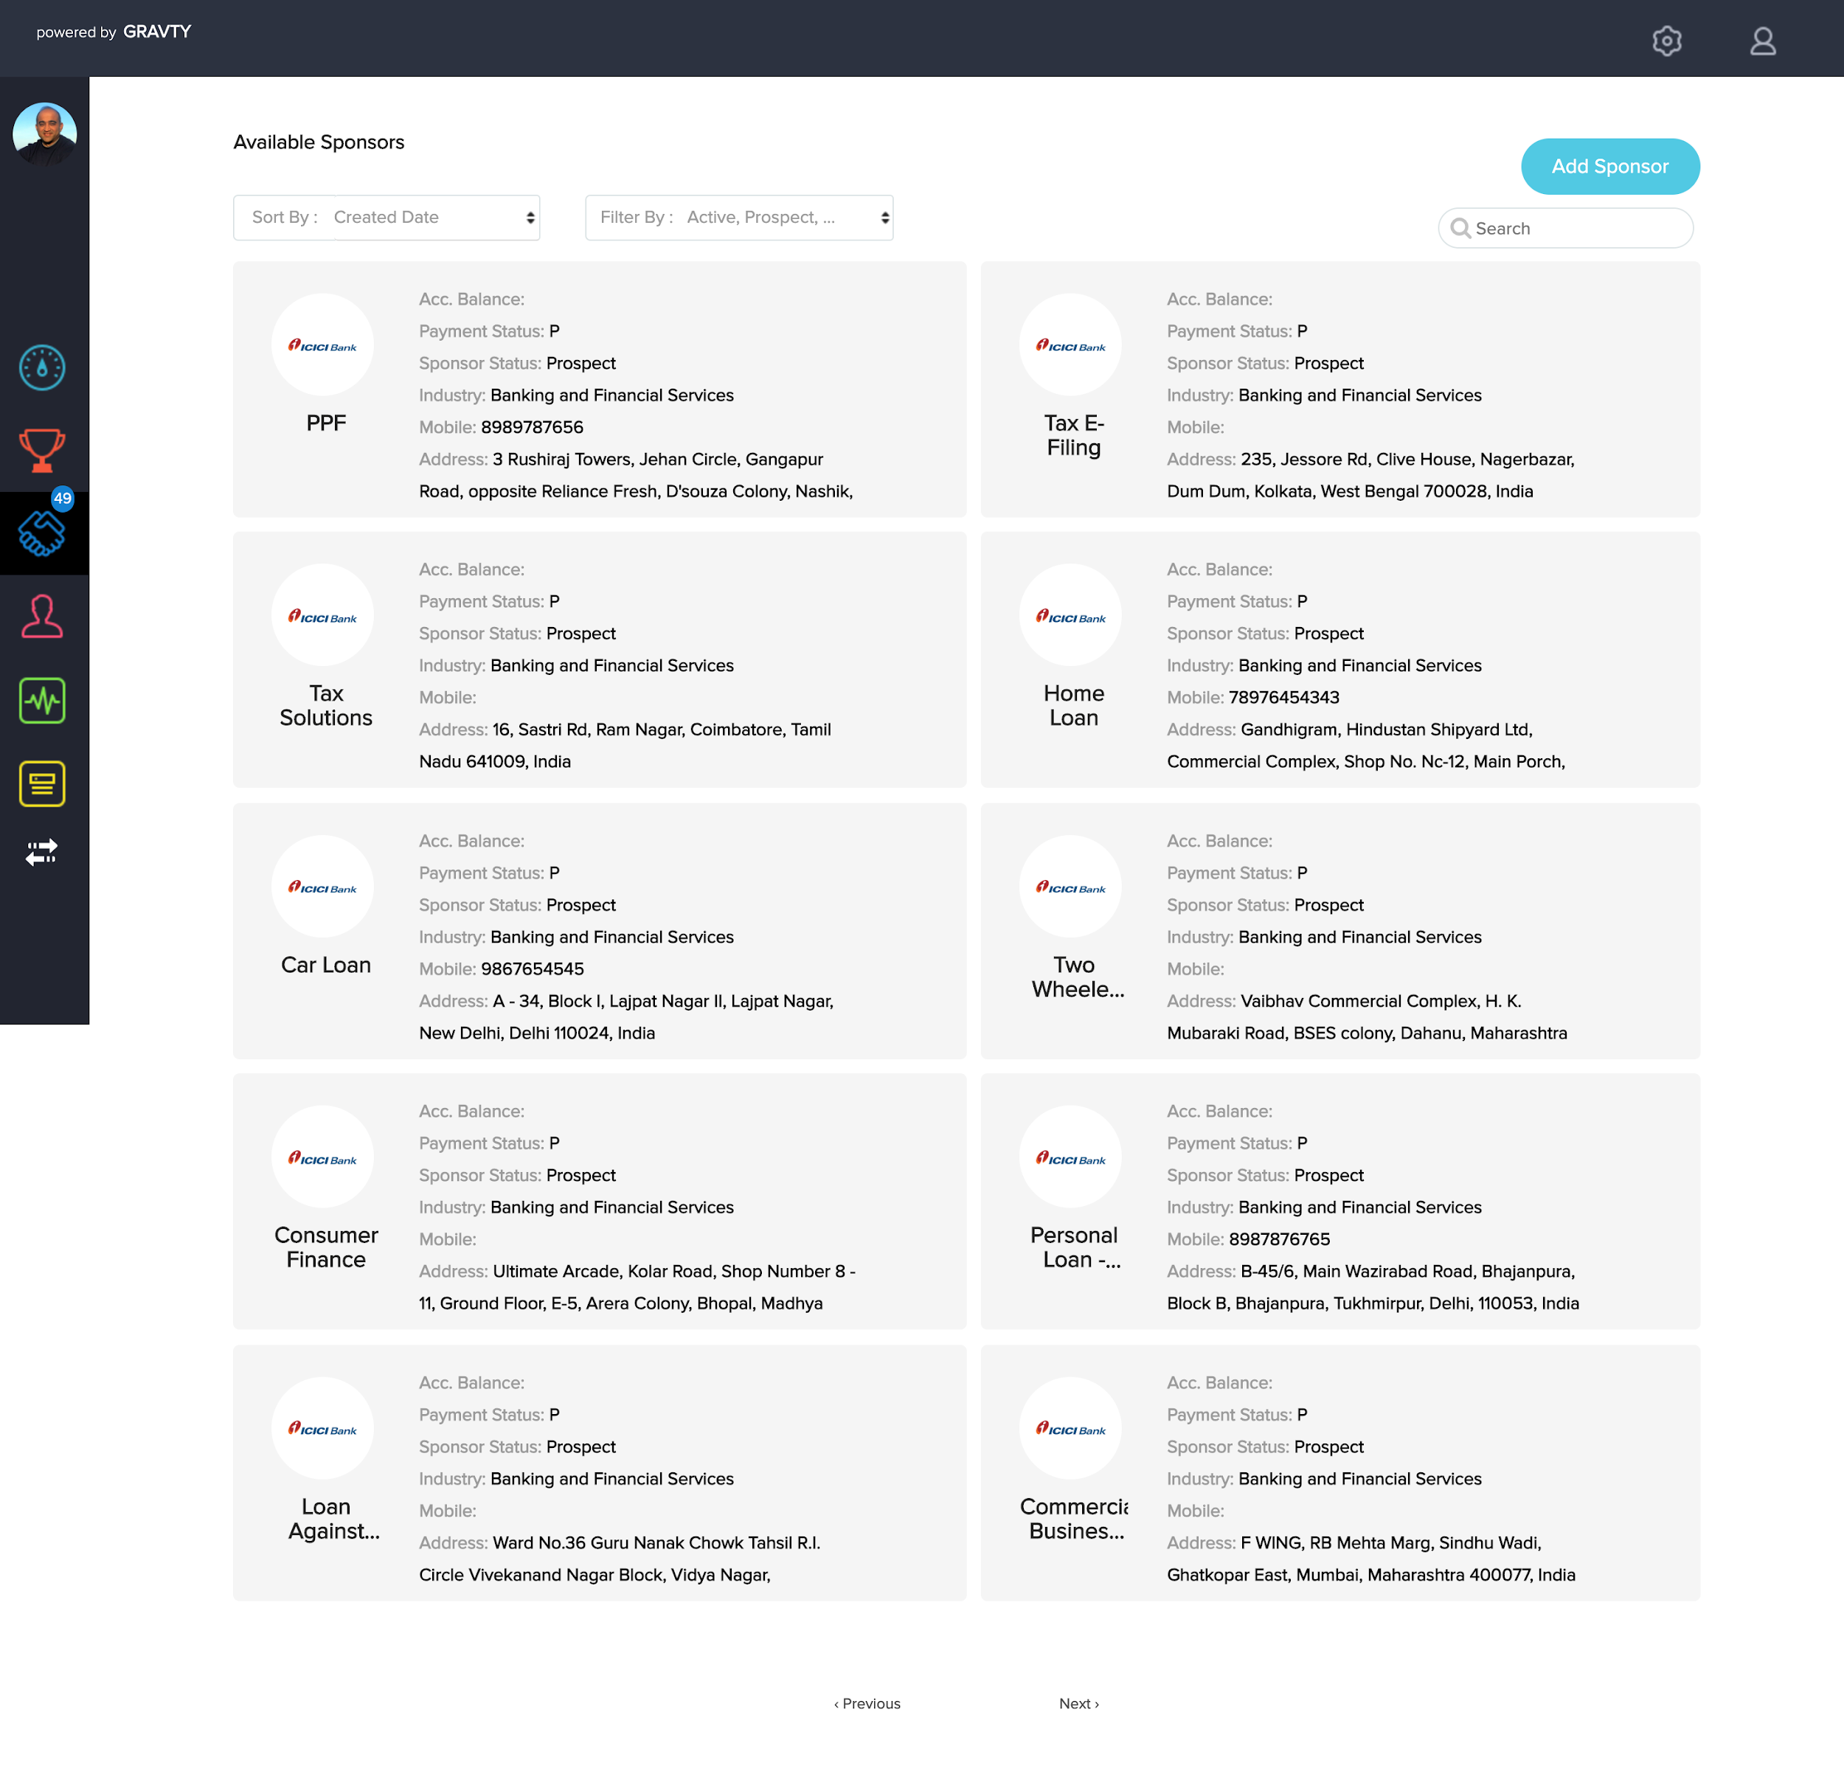

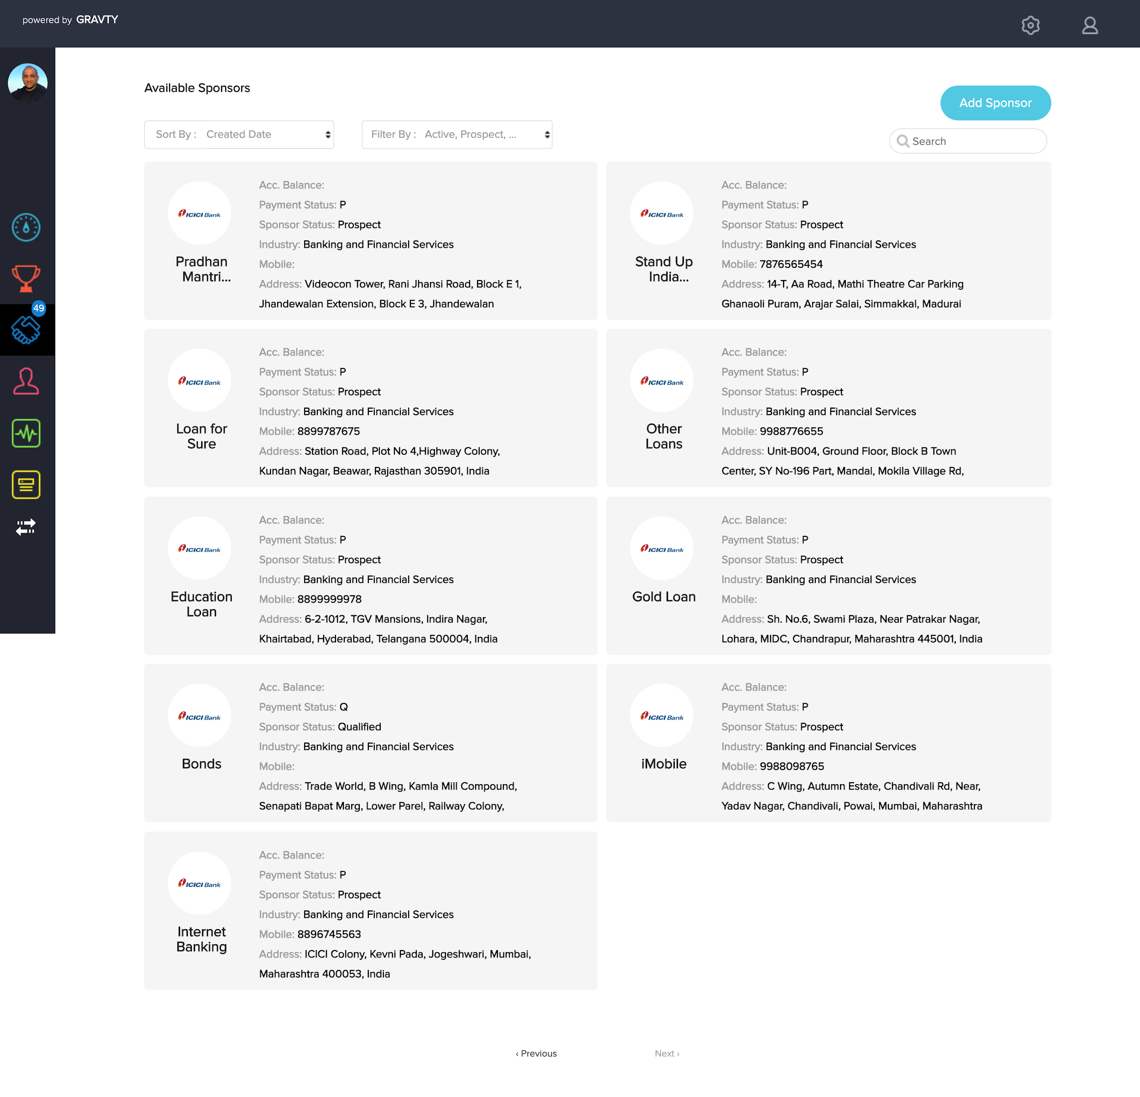

### 

### 

### 

### 

### 

### 

### 

### 

### 

### 

### 

### 3.1.1 Three tier structure of ICICI Bank

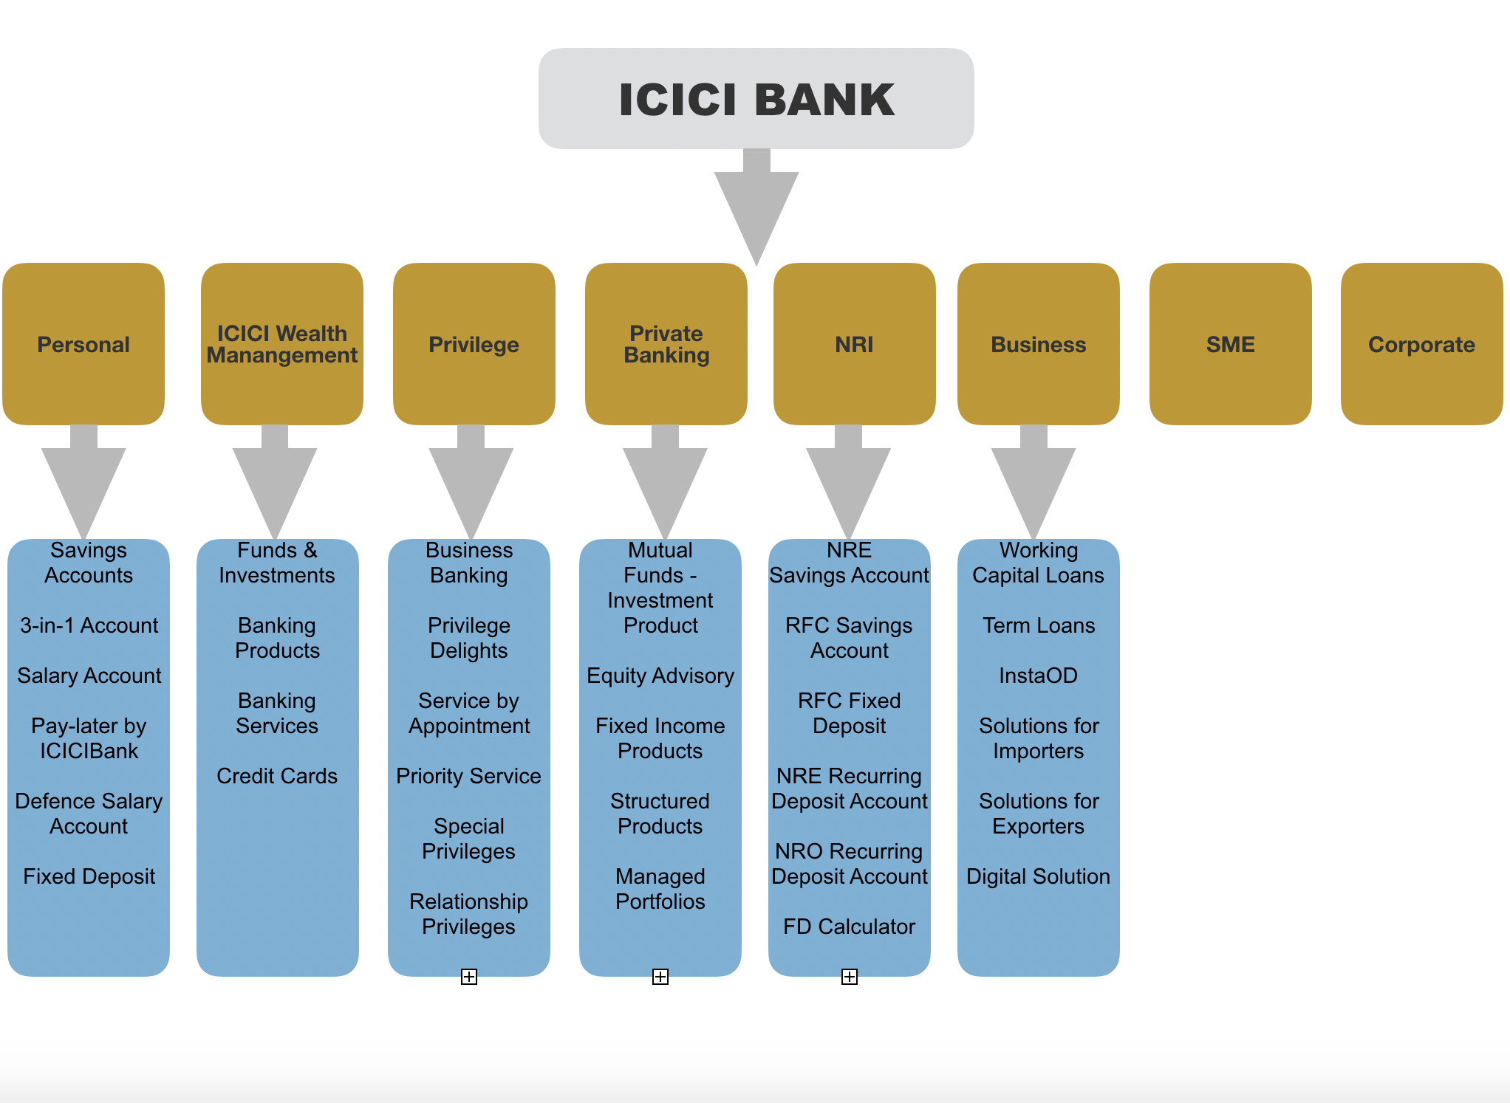

Here ICICI Bank would be the host sponsor, followed by all it’s verticals which is further followed by types of sponsors that would come under individual verticals.

.

## 

## 

## 

## 

## 

## 

## 

## 

## 

## **3.1 Offer Setup**

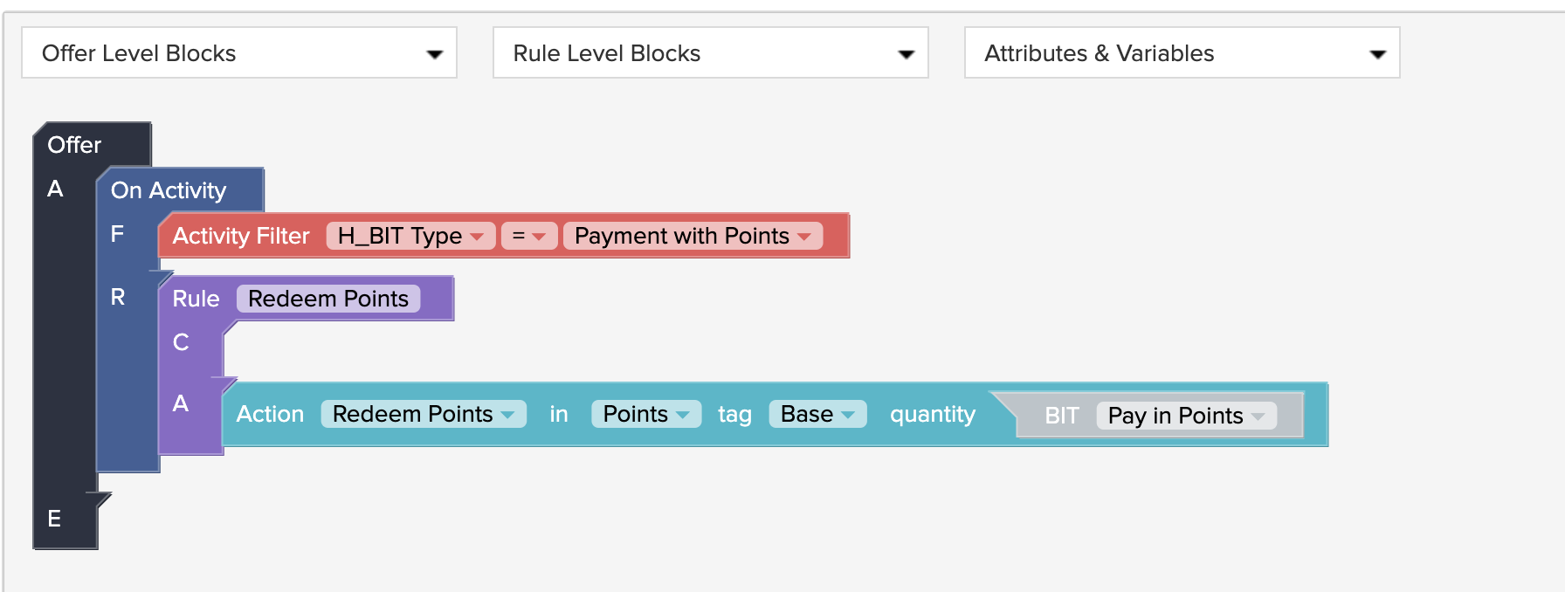

The offer states that if the member wishes to make payment with points then points would get redeemed from his account.

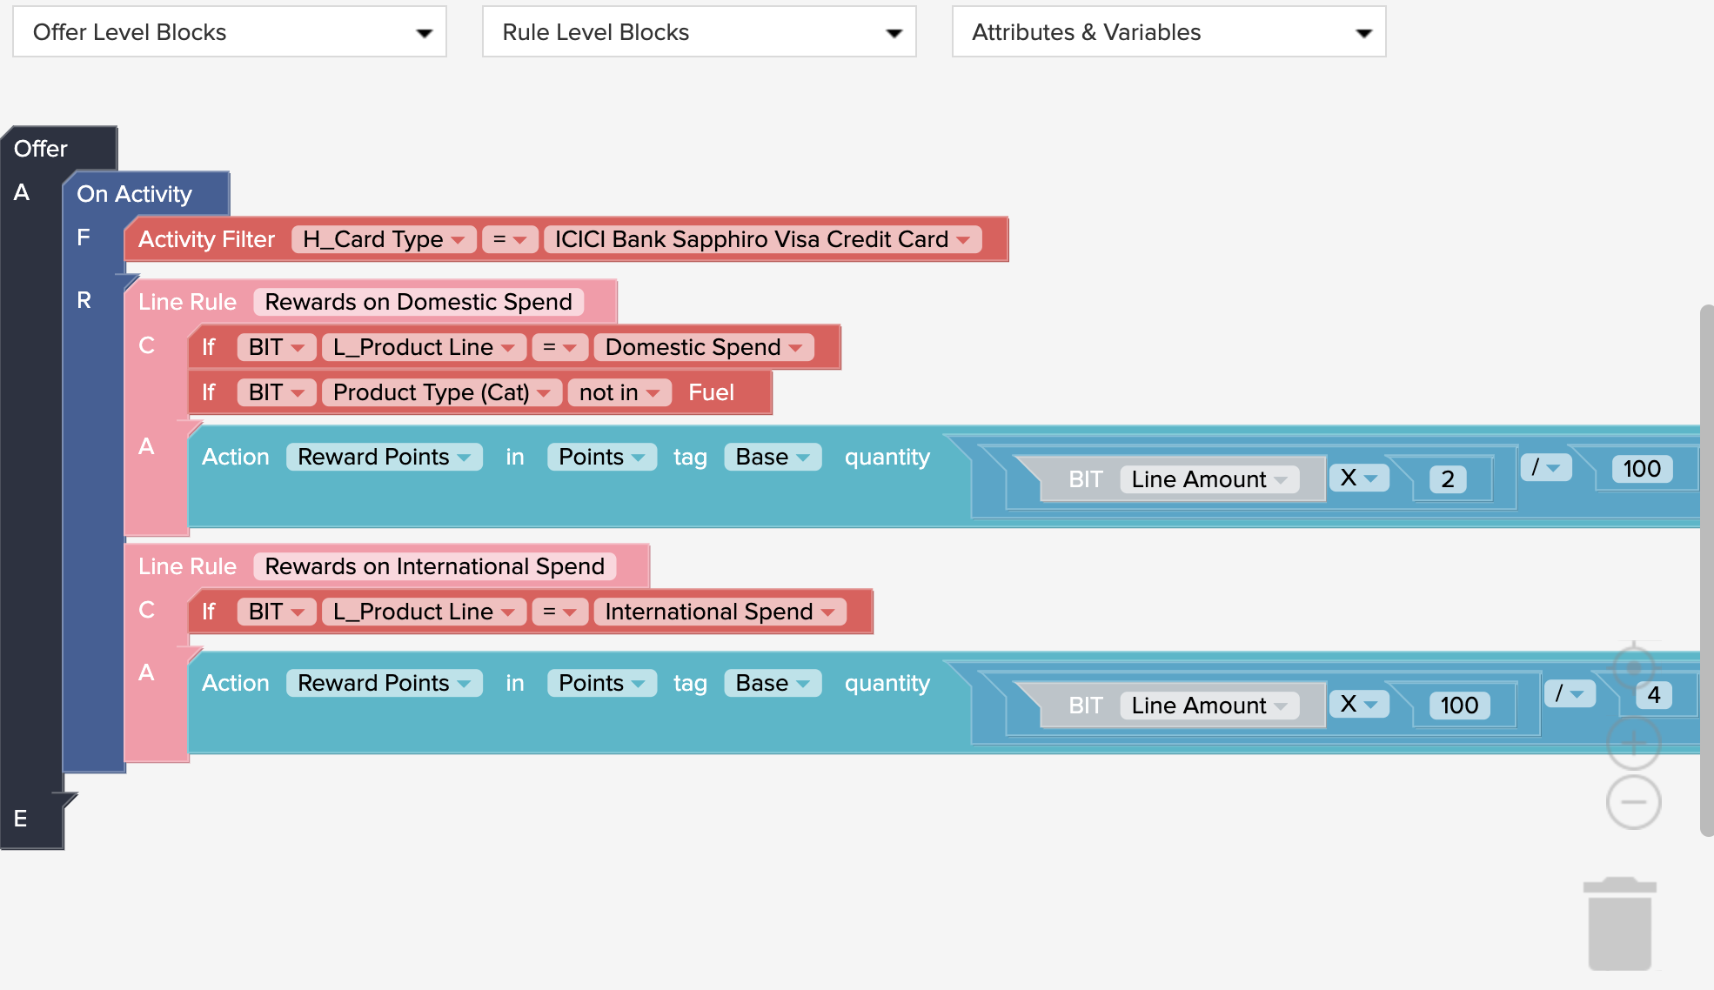

The offer would filter out the customers who have used ICICI Bank sapphiro visa credit card. Later for the people who have made some domestic spend excluding the spend done on fuel then the member will be awarded two times the amount spent divided by 100. Similarly, for international spend the member will be awarded 100 times the amount spent divided by 4.

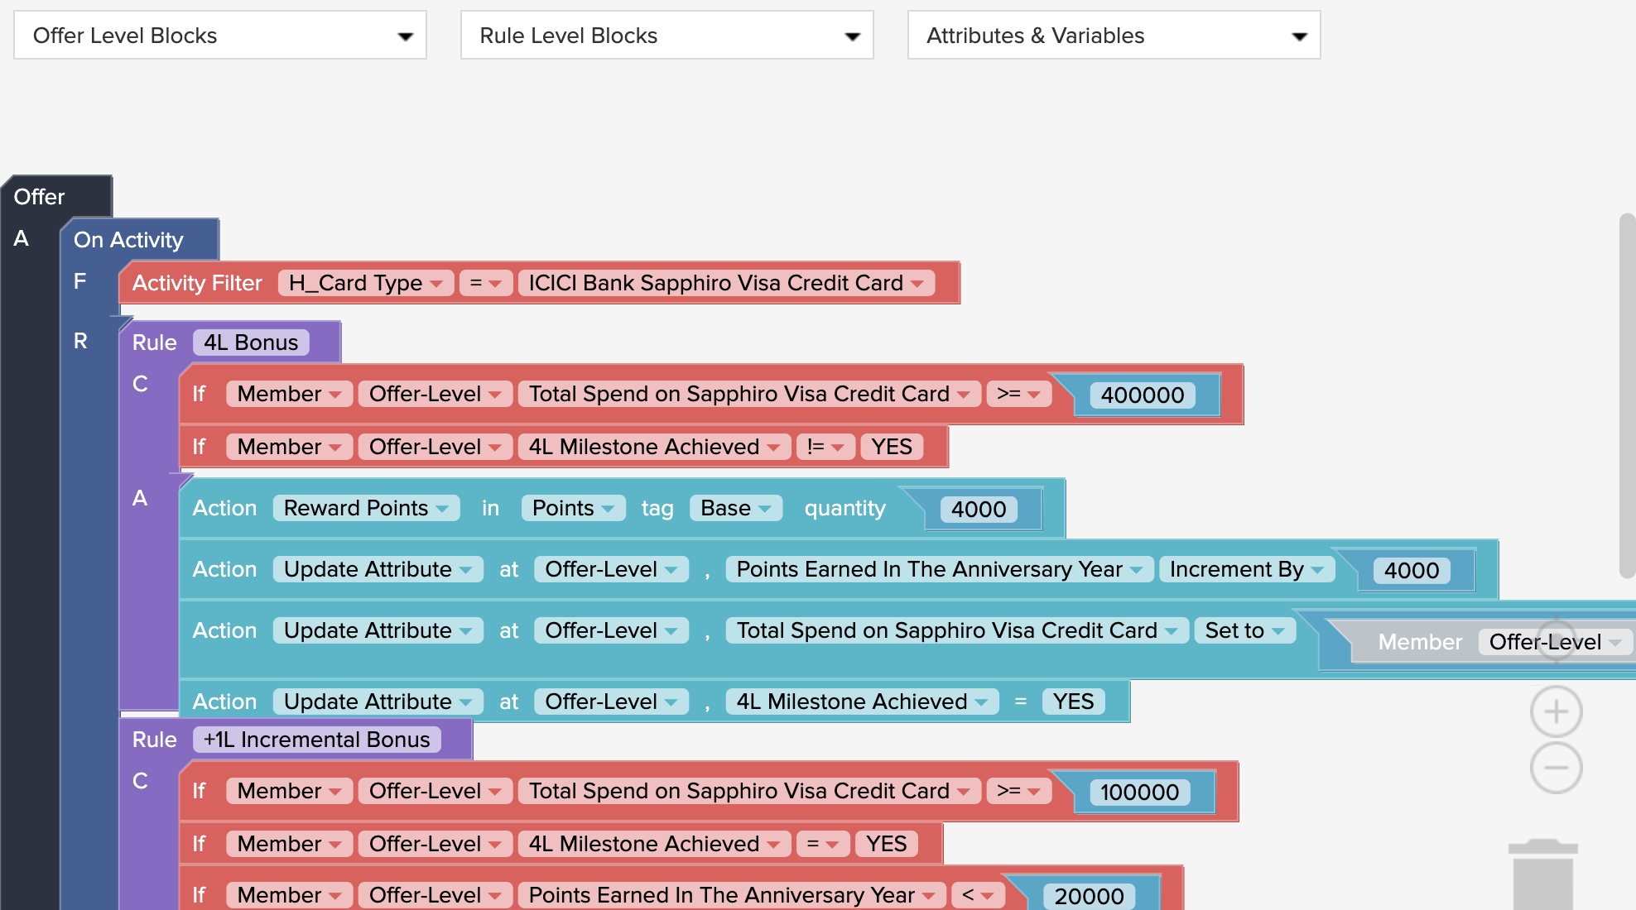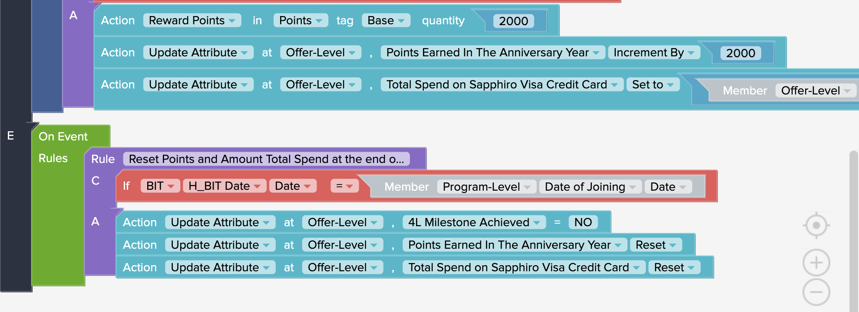

The offer would filter out only those people who have used ICICI Bank Sapphiro Visa Credit Card. If the spend amount is greater than or equal to 400000 and if 4L Milestone is achieved then reward the member with 4000 points also get added during the anniversary year. The amount spent on a visa card is then set to 4000 also the status of 4L Milestone achievement is set to ‘yes’. Accordingly the offer would get activated based upon different amounts spent.

**4.1 Batch Setup**

The Member data and transaction data from the ICICI Bank Data warehouse is uploaded on the Batch Interface (SFTP) and this data from batch interface is downloaded not in real time but at defined time intervals in Batches. The offer target member data is uploaded on Batch Interface (SFTP) by GRAVTY and the Offer target files are further downloaded by the bank which will be used to notify the target members via sms or emails.

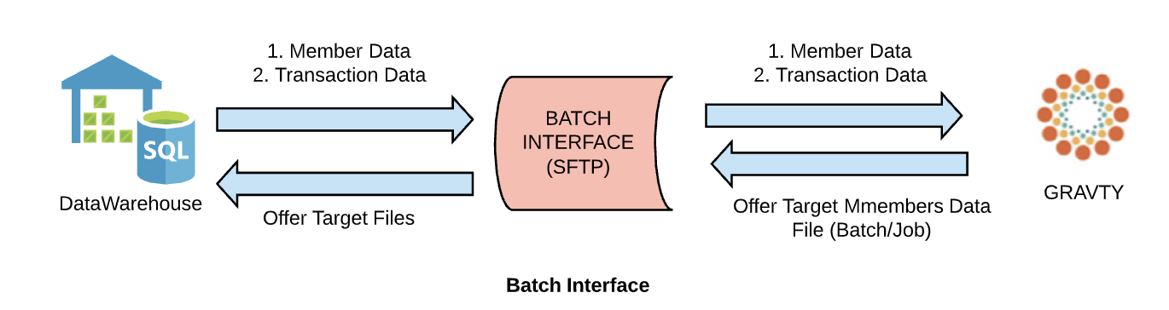

**6.1 iMobile Application Flow**

GRAVTY will send available offers and privileges to the target members to IMOBILE app and the members are then redirected to third party vendor then verifies the offer and privileges with GRAVTY and GRAVTY then marks the offer/privilege as USED for the specific member on the app. Imobile will send FED Id then identify member id(ucic) and send imobile offers to GRAVTY.

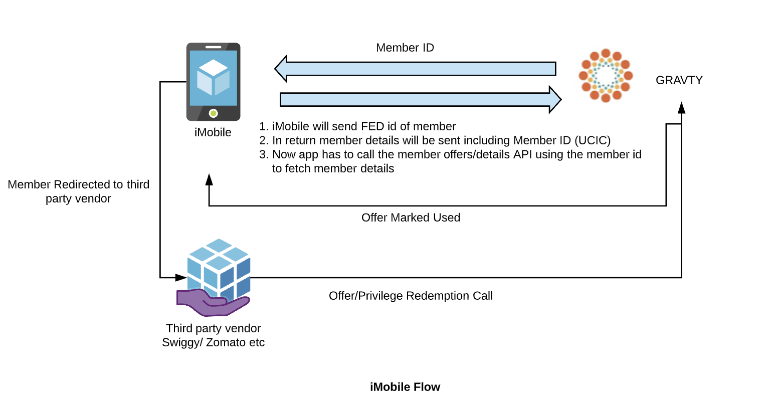

# **iMobile App Requirements & Solution**

1. **Category based filter in the offer**

Requirement is to filter the offers in the iMobile application based on the different type of categories. The example of categories are Travel, F&B, Electronics, etc.

**Solution**

In the offers we will have an attribute called ‘Offer Category’ which will be an offer extra attribute. The fetch offers API will get the offers and display in the Application based on the category coming from the GRAVTY.

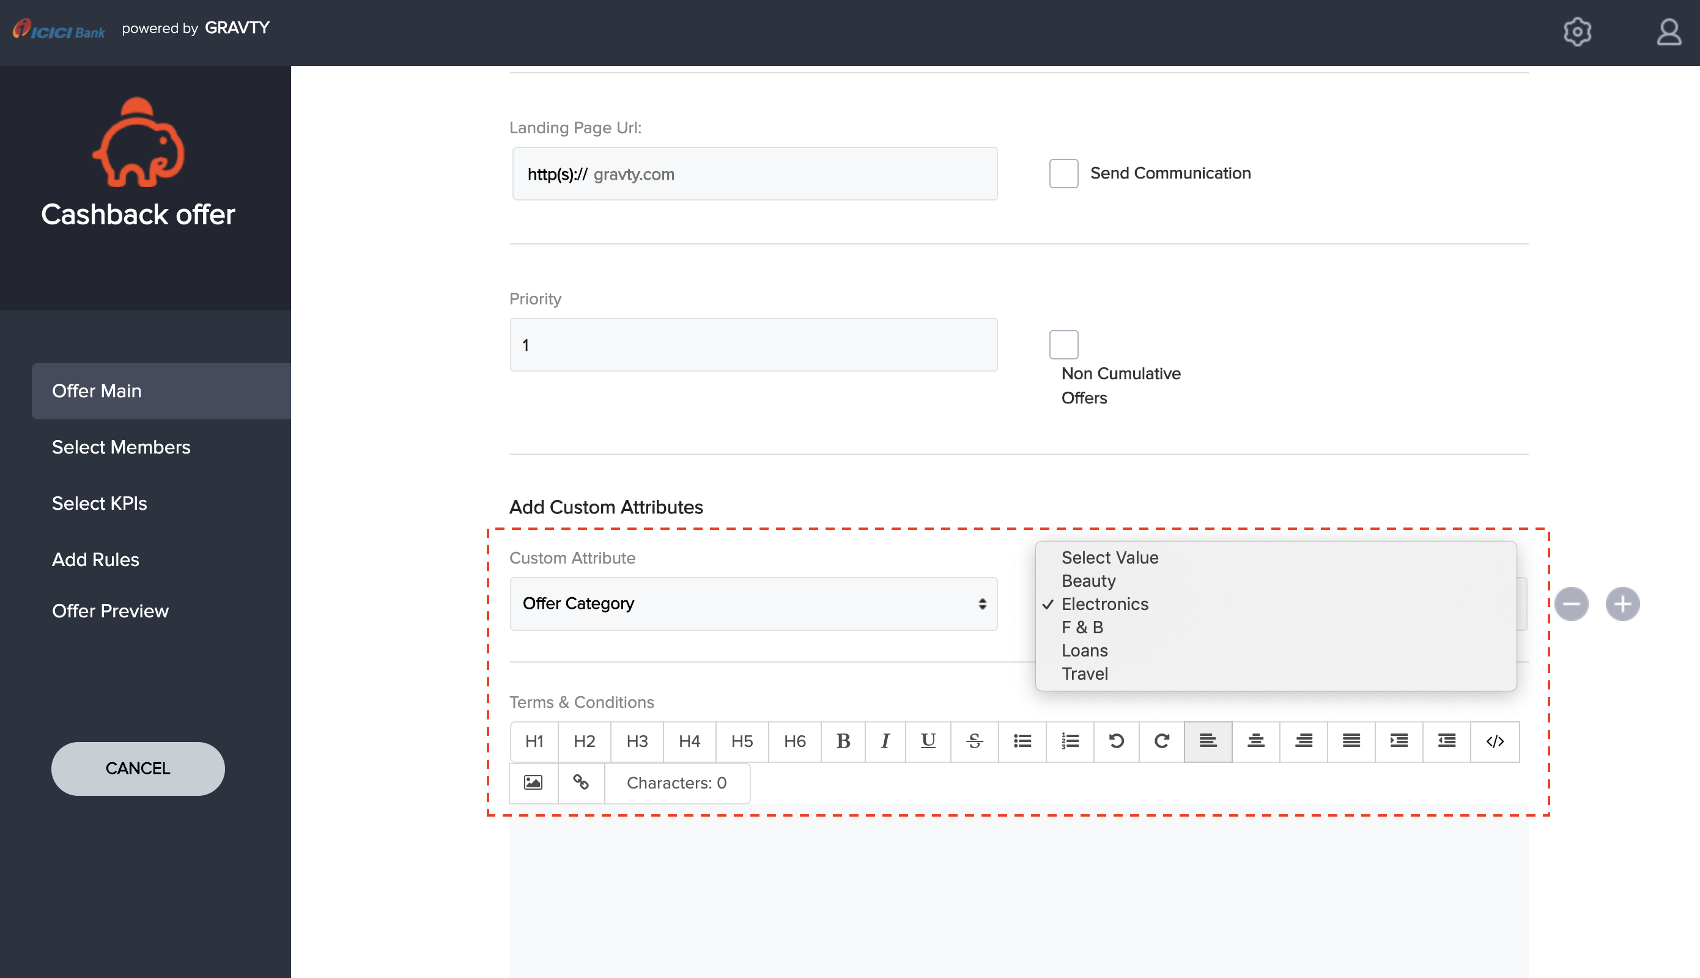

1. **Portfolio Offer**

Members are given an option to Accept the offers, i.e. member will enrol for the offer which he/she wishes to redeem. Then these offers are stored in member’s saved offers within the application which the member can go and redeem.

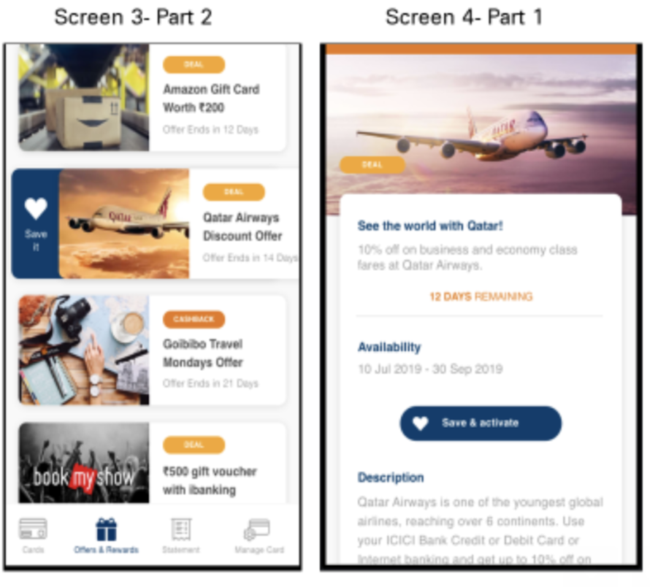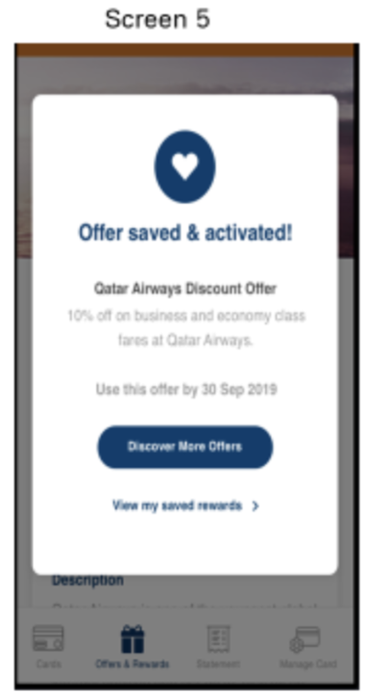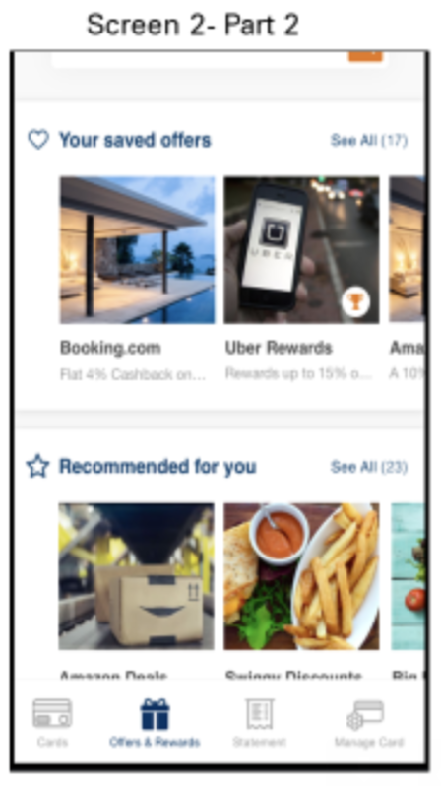

**Solution**

Via offer acceptance members will be asked to enroll for the offer, if member enrolls then only the member will be eligible to use the offer otherwise not.

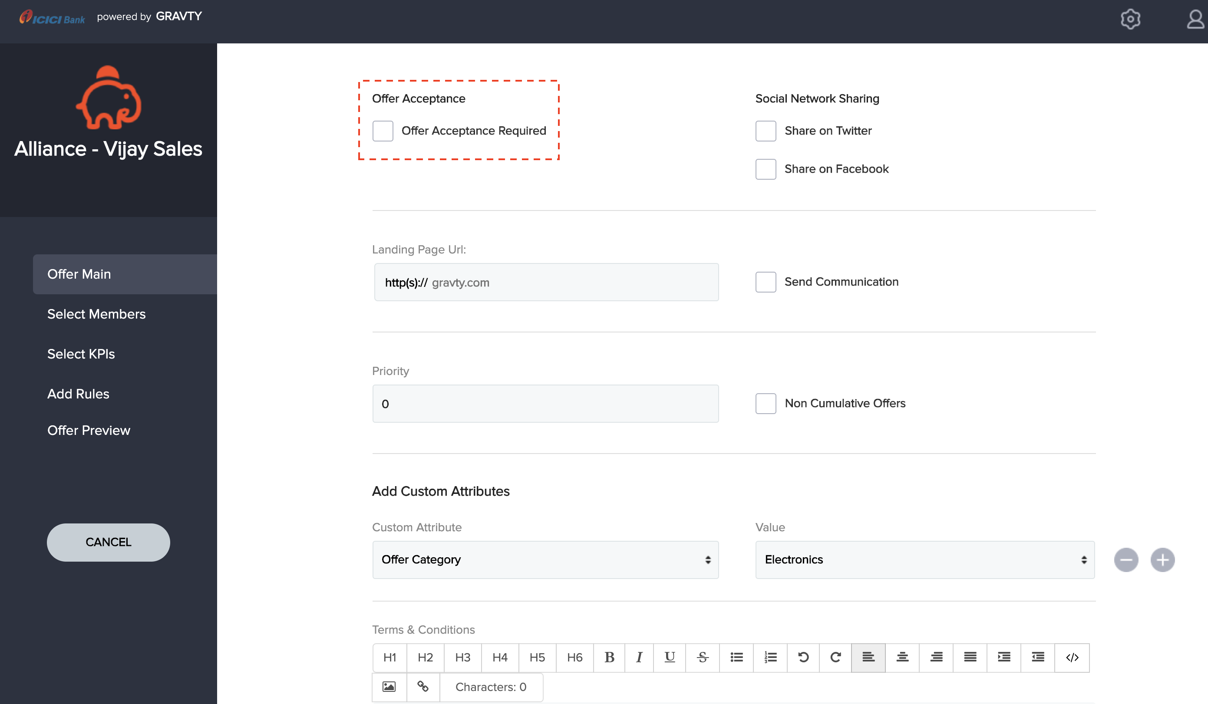

1. 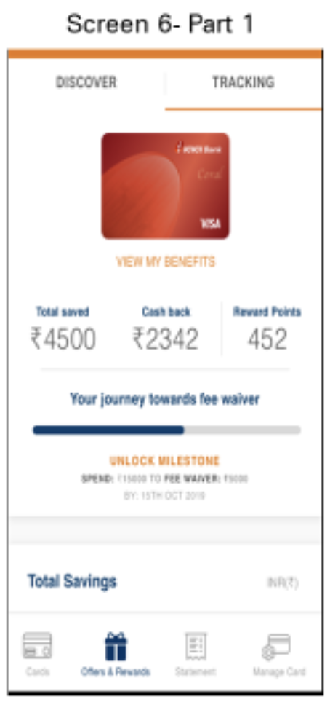**Display and store cumulative cashback given via offers**

The offers are of two types, first one is the Fixed Discount offers and the second one is the Cashback Offers in which a fix amount of cashback will be given to the members.

**Solution**

To capture and cumulate the total cashback values we have configured an loyalty account called Cashbacks. In this loyalty account member will get the cashback. Mobile app can anytime fetch the total cashback balance and transactions from which the cashback was given to the member.

## 

### 

### 

### 

#### 